Xanthe Kraft and Patrick Xu
Fancy Application Final Report

“Pi Time”: The Line Wait Time Estimator
Overview
Inspired by the HOP Courtyard Café’s tremendously long lines during peak hours of the school year, we present “Pi Time”, a line wait time estimator as a function of line length. During peak hours, lines at dining locations such as the HOP and KAF are extremely long. Often, students attempt to avoid the long wait by going at what they hope to be off-peak hours. “Pi Time” takes the guesswork out of minimizing time spent in line by giving users up-to-date wait time estimates of the dining location. The final product of our work can be viewed at http://www.cs.dartmouth.edu/~patxu/.

Components
HC-SR04 Ultrasonic Range Sensor: Measures distance to a large (>0.5 m²), nearby (advertised 2-400cm) surface by timing reflections of ultrasonic waves (“Micropik”).
Raspberry Pi Client (./client/): The client code interfaces with the HC-SR04 ultrasonic distance sensor, reads in timing data, converts it to a distance, and sends it to the server. It takes the server response and prints it out. The client also prompts the user for desired distance units to be used in the values printed out in the client console.
Server (./server/): The server takes in the client message, which is a distance in centimeters. First, it sends the distance value back to the client with a maximum of two decimals and the client-specified unit of length (e.g. 23.90 cm). Then, it creates a custom “Reading” object and sets its distance value equal to the one it just received from the client. It saves one object in the Parse database for each client message.
Web Interface (./website/): the Pi Time website uses JavaScript to query the Parse database every 2 seconds for the 10 most recent “Reading” objects. It takes the average distance and gives it to the function (see below) to relate line length and wait time. Then, it nicely formats the wait time and displays it for the appropriate dining location. The interface of the website is written in HTML and utilizes the Bootstrap CSS library.
Line Length-Wait Time Function: The function takes in a line length and outputs a wait time. The function is derived from research on KAF wait times. The function is as follows:

Wait Time (sec) = 7.416 × (Line Length (ft) ) + 1.810

Data Flow Diagram
Parse API
HTTP
wired connection
Offsite
Dining Area
wait time estimates
Parse object

Parse API
Parse objects
distance
voltage high/low
Sensor
Pi (converts time interval to distance)
Parse Database
Server
Web Server (converts distance to time)
User
HTTP
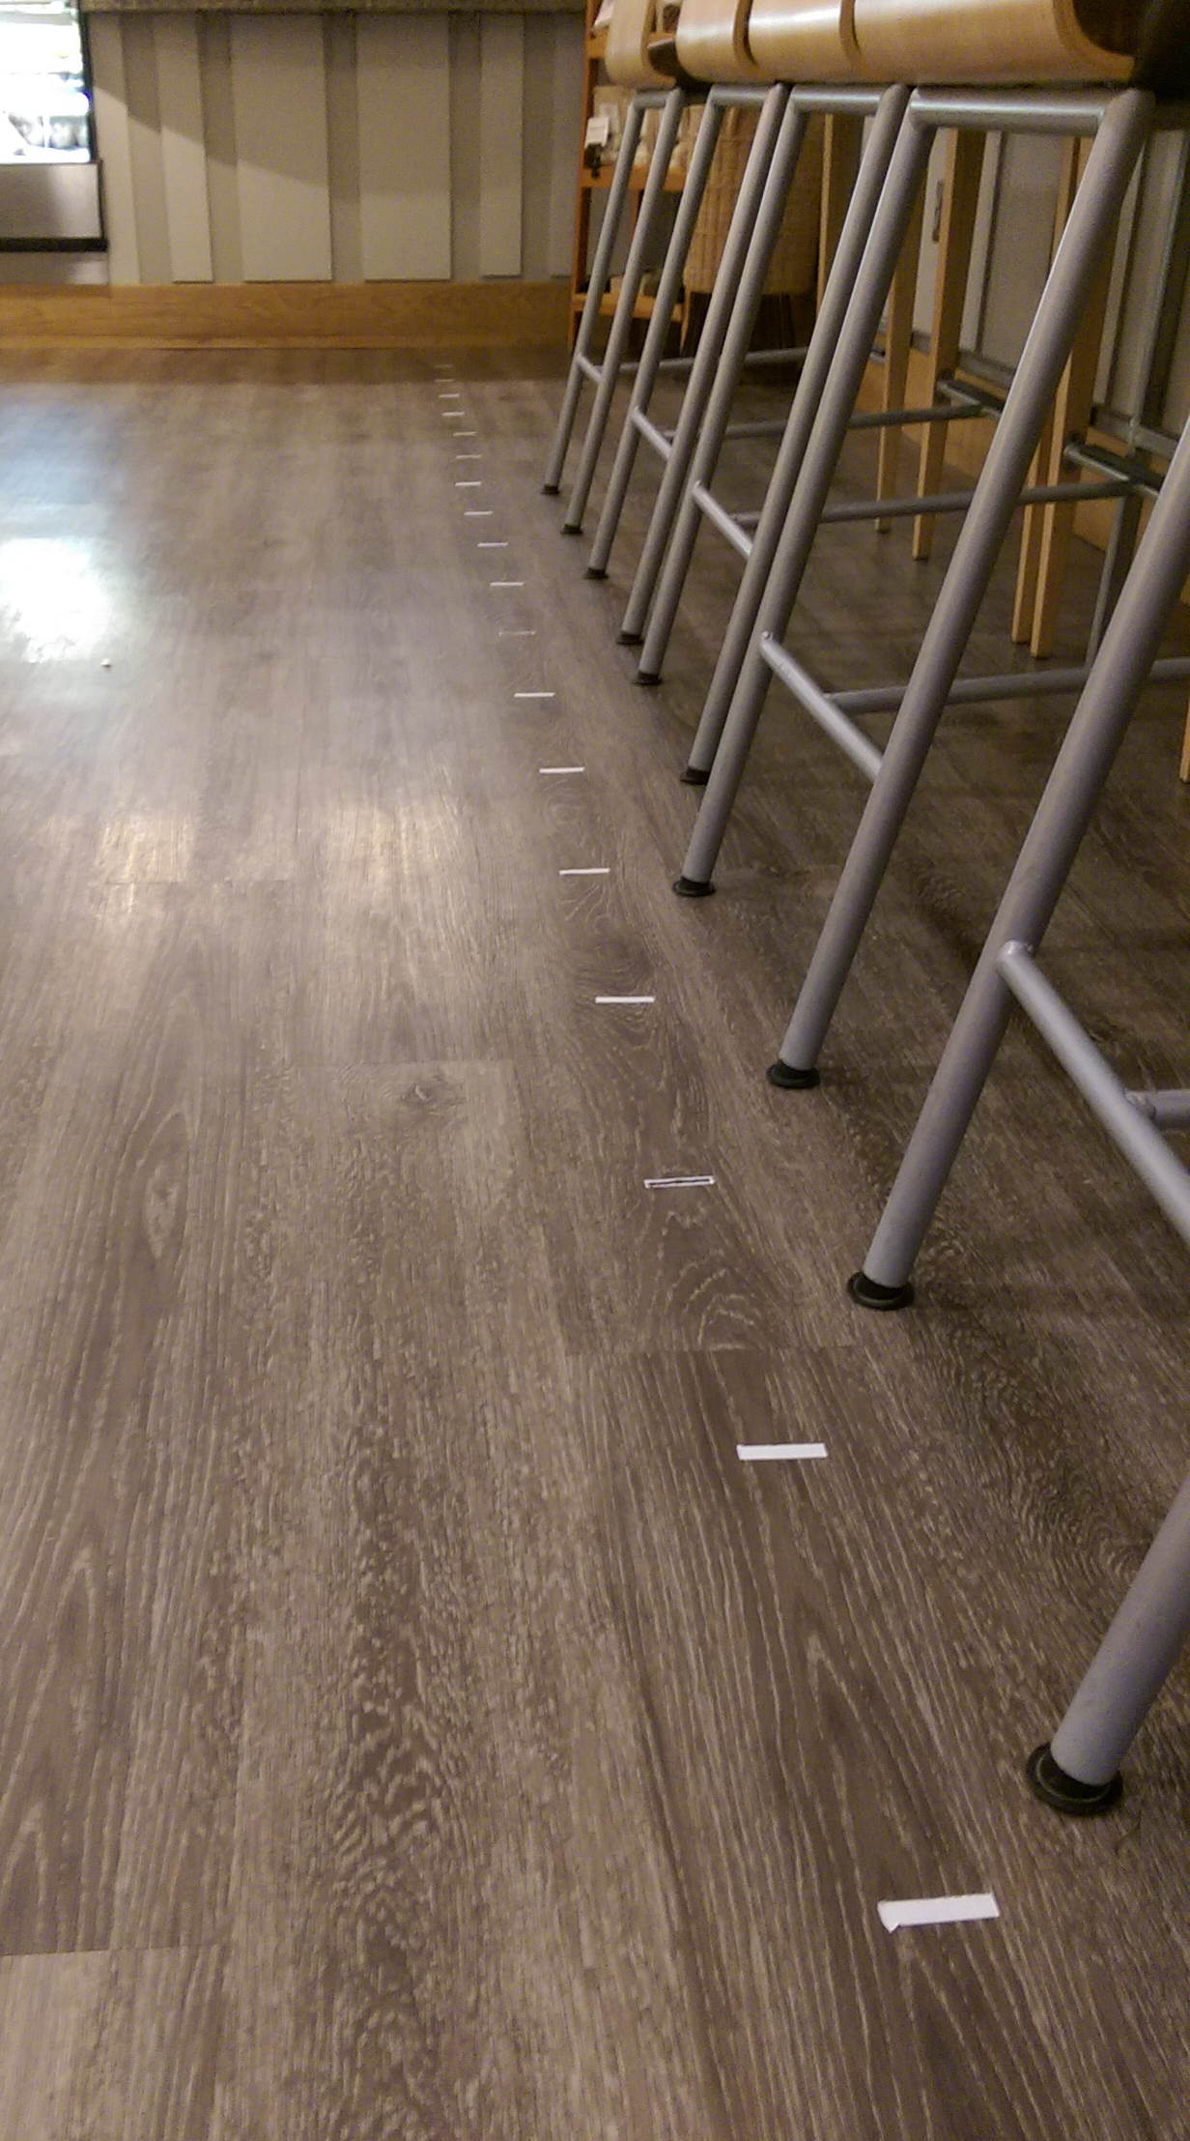

Methods and Testing
Our first goal was to study the relationship between line length and wait time. First, we obtained permission to test in KAF from both KAF and Baker Library management. Then, starting from the front of the counter, tape was placed in one foot intervals towards the back of the line, up to 18 feet. Then, starting at 8:20 AM, as users entered the line we noted 3 things: the time at which they entered the line, the distance from the counter when they started waiting, and the time they were served. The data is plotted below.
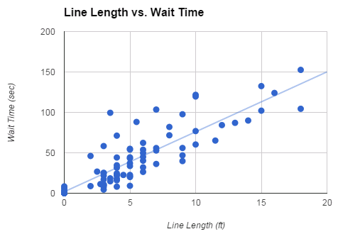
Thus, we were relieved to discover a

Alongside our observational research, we set up the sensor in KAF in an attempt to gather reliable line length measurements. Unfortunatly the sensor was accurate to only 2 feet, after which measurements had extremely high variability. Upon further research, possible factors to reduce the effective range of the sensor include external noise, non-parallel reflecting surfaces, and unpredictable reflection patterns where waves would take longer, indirect routes to and from objects and the sensor(“Arduino”). Later, in an empty control room (Berry 171C) we tested the sensor and found it fairly accurate up to 8 feet and then slowly becoming more and more variable. We also found that a large flat surface, like a white board, gave the more consistent readings. The demo video is done in this control environment for accurate sensor readings.

Obstacles
The HC-SR04 Ultrasonic Range Sensor, while boasting an accuracy up to 5 meters, only worked reliably up to 12 feet in a controlled environment, and 2 feet in a noisy, moving environment (which would be the actual commercial site of the detector). The noisy surrounding is incompatible with the functionality of the sensor, which was skewed by the the reflection of sound waves, and irregular surfaces.

Changes in Direction
We changed direction several times throughout the course of the project. We started with no concrete idea of how to correlate distance to wait-time, and ended up with real-time observation to find a linear regression between wait-time and length from sensor to the line (from behind). We also originally planned to test our device in the HOP since it has the most linear line, but we had to switch to testing at KAF since the HOP is closed during the summer. KAF was less desirable, but in the end our sensor didn’t work in the commercial location at all, and we tested it in a controlled setting. We had to change the location of demo because of sensor limitations, and if more time was available to us, we would have tried a different sensor as well.
The website itself went through many prototype stages, with the modules and text aligned in the left, but eventually we settled on a color scheme and center formatting.

Future Research and Continuation of “Pi Time”
For Pi Time to be commercially successful, we would need a different sensor (laser sensor): one unaffected by external noises, narrow detection width, and accurate up to 20 or more feet. With these precise lengths, a statistical correlation between line distance and wait time would be measured, and all wait times could be based off this new model. Furthermore, a successful device could include a wait-time algorithm that updates in real time, constantly monitoring data and determining the most accurate wait-time/ distance relationship. With a working sensor and accurate method of wait-time calculation, Pi Time could be tested in KAF and the HOP’s Courtyard Café during the regular Dartmouth school year, and additional tweaks could be made to the web-interface.

A perpetually running Pi Time apparatus could also be expanded to keep track of line-wait history— to create diagrams of the longest wait-times of the day, month, and year—and make additional comparisons of population etc. This data could be released to students and staff for an accurate allocation of resources throughout operation.
A further improvement would be moving the distance-to-time calculation from the website to the server, so that the database holds times instead of distances. This would be more useful information to store over for the long-term.
Lastly, other Pi Time sets could be created and implemented in the remaining dining options on campus, to update to their respective modules on the Pi Time website (HOP, Novack, ’53 Commons). This could complete the entire range of dining data collection at Dartmouth, and provoke further insights into what locations students choose and when. This information could be used by the administration and others to improve life on campus and beyond.

Acknowledgments
We would like to thank Sean Smith, Jack Holland, Yinan Zhang Bill Nisen, and all other COSC69.07 staff for providing expert advice, guidance, resources, and the Pi itself. Also, special thanks to Kathleen Rao for HTML expertise and photo editing.
We would also like to thank Codecademy for providing practice code adapted from “Airbnb” (https://www.codecademy.com/)
Functionality of Wait Time Estimator influenced by “LineKing” (http://www.cse.buffalo.edu/~demirbas/publications/lineking.pdf), and COSC 69.07 15X lectures.

References
Micropik. "Ultrasonic Ranging Module HC - SR04." Ultrasonic Ranging Module HC - SR04. ElecFreaks, n.d. Web. 11 Aug. 2015. <http://www.micropik.com/PDF/HCSR04.pdf>.
ModMyPi. "HC-SR04 Ultrasonic Range Sensor on the Raspberry Pi." Cases for Your Raspberry Pi. ModMyPi, 3 July 2014. Web. 11 Aug. 2015. <http://www.modmypi.com/blog/hc-sr04-ultrasonic-range-sensor-on-the-raspberry-pi>.

References for the Website
Arduino. "HC-SR04 Gives Max Range of ~60 Cm." HC-SR04 Gives Max Range of ~60 Cm. Arduino, 11 Sept. 2012. Web. 11 Aug. 2015. <http://forum.arduino.cc/index.php?topic=122397.0>.
Brunner/Cott. Class of 53 Commons. N.d. Web. 9 Aug. 2015. <http://brunercott.com/BC_portfolio/1.BC_academic/1.BC_campus_ctrs_dining/02.Dartmouth_Commons/2_Dartmouth_opt.jpg>.
Dart Review. KAF. N.d. Web. 9 Aug. 2015. <http://www.dartreview.com/wp-content/uploads/2012/02/sq-let-them-eat-kaf.jpg>.
Dartmouth College. Novack. N.d. Web. 9 Aug. 2015. <http://dartmouth.edu/sites/default/files/styles/header_image/public/2008-0009038275.jpg?itok=WzketlBb>.
Hotel Coolidge. The HOP. N.d. Web. 9 Aug. 2015. <http://www.hotelcoolidge.com/wp-content/uploads/2014/10/HOP-outdoor-image-sm.jpg>.

- A full description of what the project looks like (because most projects have had significant changes in direction). Clearly state the specific problem the project solves.
- The algorithm used to solve the problem. (Specify the input variables explicitly and sensors each variable data is from )
- Diagram of the software structure (or data flow). Show the IoT structure we've been covering in class: where the sensors/actuators are, where all the places computation is happening (Pi, server...anywhere else?), and the communication channels.
- Results of experiments. (At least one test case)
- Future work: how you would expand the work in the future.

